***FOURTH SEMESTER ECD PROJECT REPORT***

**Water level indicator with auto-cut**

*Submitted by*

Divyashree Dey (210907156)

Paarangam Roy (210907164)

Harsh Kumar Singh (210907180)

P S Chainika Vaishnavi (210907196)

**DEPARTMENT OF ELECTRONICS AND COMMUNICATION ENGINEERING**

**MANIPAL INSTITUTE OF TECHNOLOGY**

(A Constituent Institution of Manipal Academy of Higher Education)

MANIPAL – 576104, KARNATAKA, INDIA

**APRIL**

**ABSTRACT**

A water level controller is an electronic device that is designed to control the level of water in a tank. This project aims to create a reliable and efficient water level controller using various electronic components, such as relays.

The Water Level Indicator employs a simple mechanism to detect and indicate the water level in an overhead tank or any other water container. The sensing is done by using a set of three probes which are placed at three distinct levels on the tank walls (with probe 3 to probe 1 placed in increasing order of height, a common probe (i.e. a supply carrying probe) is placed at the base of the tank). Level 3 represents the "tank full" condition while level 1 represents the "tank empty" condition.

The project aims to reduce the wastage of water by automatically switching off the water supply/ pump when the water reaches a specific level in the tank. This model can have various applications like indicating the level of water in the tank, and bigger applications like alarming when the water in the dam reaches above the safety level.

**CONTENTS**

Chapter name Page Number

*1: Introduction 4*

*2: Literature Survey 5*

*3:Methodology 6*

*4:Result analysis 11*

*5:Conclusion and scope for future work 12*

*References 13*

*Plagiarism report 14*

**CHAPTER 1- INTRODUCTION**

A water level indicator is an electronic device used to monitor the water level in a tank or reservoir. It is a useful tool in situations where it is essential to maintain a certain level of water, such as in a water tank for a household or a swimming pool.

The water level indicator works by using sensors that detect the water level and provide a signal to the circuitry of the device. The circuitry then processes this signal and displays the water level using LEDs or other display mechanisms.

In addition to monitoring the water level, a water level indicator can also have an auto cut-off function, which automatically turns off the water supply when the tank is full. This function is particularly useful for preventing overflow and conserving water.

One way to achieve this auto cut-off function is by using a 555 timer IC. The 555 timer IC is a versatile integrated circuit that can be used in a wide range of electronic circuits, including water level indicators.

In this project, the 555 timer IC is used to trigger a relay that controls the water supply. When the water level reaches a certain point, the sensor sends a signal to the 555 timer IC, which triggers the relay to turn off the water supply. The circuit can also be designed to trigger an alarm to alert the user when the water level reaches a certain point.

In households, such devices are commonly used to monitor the water level in overhead tanks and prevent overflow. This is particularly useful in areas where water scarcity is a common problem. The auto cut-off function ensures that the water supply is turned off once the tank is full, thus saving water and reducing wastage.

In industries, water level indicators are used in large water storage tanks and reservoirs to monitor the water level and prevent overflow. This is crucial in industries such as power generation, where water is a critical component for cooling and steam generation.

Overall, a water level indicator with auto cut-off using a 555 timer IC is a useful and efficient tool for monitoring and controlling the water level in a tank or reservoir.

**CHAPTER 2- LITERATURE SURVEY**

Several studies have been conducted on the design of water pumps with auto cut. For instance, Oloyede et al. (2015) developed an automatic water pump controller with overload protection, which uses a relay to control the pump motor and a sensor to detect the water level. Similarly, Syazwan et al. (2018) designed an automatic water pump controller based on a microcontroller, which can detect water level, pressure, and flow rate. These studies demonstrate the importance of incorporating sensors and microcontrollers in the design of water pumps with auto cut to ensure accurate and efficient operation.

Operation of water pump with auto cut:

The operation of water pumps with auto cut involves the use of sensors to detect the water level or pressure and automatically turn off the pump when the desired level is reached or exceeded. Adebayo et al. (2014) developed an automatic water pump controller with under voltage protection, which can shut down the pump when the voltage drops below a certain level. In addition, Sattar et al. (2014) developed an automatic water pump controller with SMS notification, which sends a text message to the user's phone when the pump is turned off due to low water level or other issues. These studies highlight the importance of incorporating safety features in the operation of water pumps with auto cut.

Performance of water pump with auto cut:

The performance of water pumps with auto cut can be evaluated based on various parameters, such as efficiency, reliability, and durability. Rahman et al. (2014) developed an automatic water pump control system using a programmable logic controller (PLC) and evaluated its performance based on the time taken to fill a tank and the energy consumption. Similarly, Abdullah and Saifullah (2016) developed an automatic water pump control system using Arduino and evaluated its performance based on the power consumption and response time. These studies demonstrate the importance of evaluating the performance of water pumps with auto cut based on multiple parameters to ensure their effectiveness and efficiency.

The methodology for building a water level indicator with auto cut-off using a 555 timer IC can be divided into the following steps:

**CHAPTER 3- METHODOLOGY**

Gather the necessary components: To build a water level indicator with auto cut-off using a 555 timer IC, you will need the following components:

1. 555 IC
2. BC547
3. Ln4007
4. LED
5. 1k resistor (2)
6. 22k resistor (2)
7. 180k resistor (1)
8. 1M resistor (2)
9. 100 nf capacitor
10. 12V relay

Design the circuit: Using the schematic diagram for a water level indicator with auto cut-off using a 555 timer IC, design the circuit by placing the components in the correct locations on a breadboard or PCB. The circuit design will include the sensor that detects the water level, the 555 timer IC that processes the signal, the relay that controls the water supply, and the LEDs that indicate the water level.

Connect the circuit: Connect the components in the designed circuit using wires, ensuring that the connections are secure and the components are properly placed.

Test the circuit: Test the circuit to ensure that it is working as expected. This can be done by adjusting the water level and observing the LED indicators, and testing the auto cut-off function by filling the tank with water and observing the relay’s response.

Enclose the circuit: Once the circuit is working correctly, enclose it in a suitable housing to protect it from moisture and other environmental factors.

Install the circuit: Install the water level indicator with auto cut-off in the tank or reservoir, ensuring that the sensor is properly placed to detect the water level.

*2.1 Component Specificatio*ns :

1. 555 Timer IC –

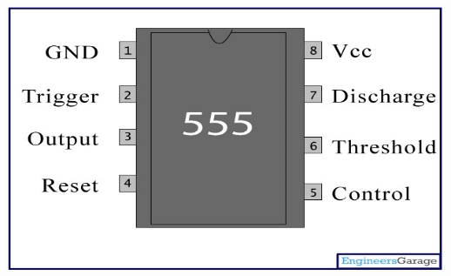

*Figure 2.1*

The 555 Timer IC is a versatile integrated circuit that is commonly used in timing and oscillator circuits. It is chosen for this project as it is readily available and can be used to control the relay, LED indicators, and other components.

1. Resistors (1k,22k,180k,1M) –Resistors are used to limit the current flow in the circuit and are chosen based on their value and power rating. The specific resistor values used in the circuit depend on the specific design requirements.
2. Capacitor (100Nf) – A Capacitor is used to store and release electrical energy in the circuit. The specific capacitor values used in the circuit depend on the specific design requirements.
3. Diodes – Diodes are used to allow current to flow in only one direction in the circuit. They are chosen based on their voltage and current rating
4. 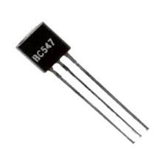Transistor (BC547) -

*Figure 2.2*

A transistor is used to amplify and switch the signal in the circuit. It is chosen based on its voltage, current, and power ratings.

1. 12 V Relay –

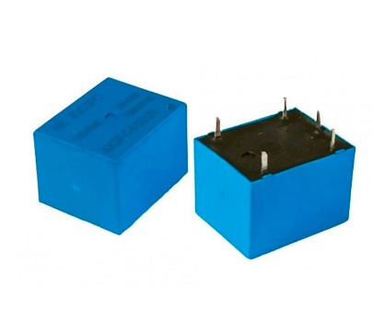

*Figure 2.3*

A relay is used to control the water supply based on the signal from the sensor. It is chosen based on its voltage and current ratings.

1. 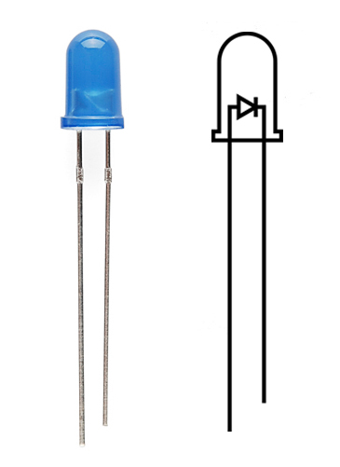LED –

*Figure 2.4*

LED are used to indicate the water level in the tank

1. Battery or Power Supply –

A battery or power supply is used to provide the necessary voltage and current to the circuit. The specific battery or power supply used depends on the specific design requirements and the power consumption of the circuit.

1. 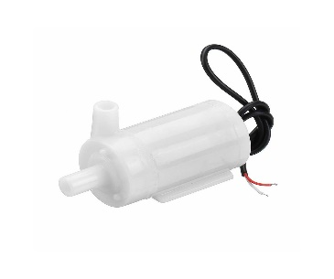Water Pump –

*Figure 2.5*

The water pump then pumps water from a water source, such as a well or a reservoir, into the tank until the desired water level is reached.

2.2 *Circuit diagram:*

*Figure 2.6*

*2.3 Tools used:*

1. PCB - PCB is used as the platform for building the circuit. The specific size and type of breadboard or PCB used depends on the size and complexity of the circuit.
2. Wire strippers - Wire strippers are used to strip the insulation from the wires and make them ready for connecting to the components. The specific wire strippers used depend on the wire size and insulation type.
3. Soldering iron and solder - A soldering iron and solder are used to solder the components to the breadboard or PCB. The specific soldering iron and solder used depend on the size and type of components being used.
4. Multimeter - A multimeter is used to measure the voltage, current, and resistance in the circuit. The specific type of multimeter used depends on the measurement range and accuracy required.
5. Power supply - A power supply is used to provide the necessary voltage and current to the circuit. The specific type of power supply used depends on the voltage and current requirements of the circuit.
6. Screwdriver - A screwdriver is used to secure the components and make adjustments to the circuit. The specific type of screwdriver used depends on the size and type of screws used in the components.
7. Wire cutter - A wire cutter is used to cut the wires to the appropriate length and remove any excess wire. The specific type of wire cutter used depends on the wire size and insulation type.
8. Pliers - Pliers are used to bend the wires and components into the appropriate shape and position. The specific type of pliers used depends on the size and type of wires and components being used.

**CHAPTER 4- RESULT ANALYSIS**

Initially the project was working fine when we assembled it on the cardboard PCB but due to some fault in the IC later it stopped working. So we bought a new IC and tried to arrange the circuit on the breadboard but for some reasons it is not working on the breadboard currently. So at this point of time, we have not yet arrived at a final conclusion.

Initial circuit

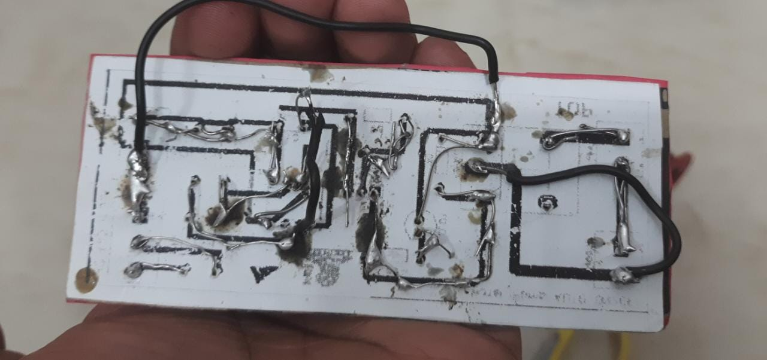

*Figure 3.1*

Current circuit

*Figure 3.2*

**CHAPTER 5- CONCLUSION AND FUTURE SCOPE OF WORK**

In conclusion, a water level indicator with auto cut-off using a 555 timer IC can be an effective and reliable solution for monitoring and controlling the water level in a tank or reservoir. The use of a sensor to detect the water level and a 555 timer IC to control the pump ensures that the tank remains at the desired level, while also preventing water wastage and reducing the need for manual intervention.

Some potential areas for improvement and future work:

1. Calibration - The accuracy of the sensor and the circuit can be improved by calibrating the sensor and fine-tuning the circuit parameters to optimize its performance.
2. Power efficiency - The circuit can be optimized to reduce power consumption and improve energy efficiency, for example by using a more efficient power supply or reducing the standby current of the circuit.
3. Remote monitoring and control - The water level indicator can be integrated with a remote monitoring and control system, allowing users to monitor and control the water level from a distance using a mobile app or web interface.
4. Multiple tank monitoring - The circuit can be expanded to monitor multiple tanks or reservoirs, allowing users to monitor and control water levels in different locations from a single interface.

By identifying areas for improvement and future work, it is possible to optimize the performance of the circuit and enhance its functionality and usability.

**REFERENCES**

<https://nevonprojects.com/electronic-water-level-controller-device/>

<https://www.electronicsforu.com/electronics-projects/automatic-water-level-controller>

<https://www.electronicshub.org/water-level-controller-using-8051-microcontroller/>

<https://www.youtube.com/watch?v=XhRAyS35XEo>



